 

CS-114 Fundamentals of Programming (2+1)

DE-41 EE Semester 1

Fall 2019

**LAB REPORT # 08**

|  |  |
| --- | --- |
| **Submitted by** | **Roll No** |
| Ayesha Javaid | 285151 |
| Syndicate A |  |

Instructor In-charge: Dr. Saad Rehman

DEPARTMENT OF COMPUTER & SOFTWARE ENGINEERING

College of Electrical and Mechanical Engineering (CEME)

National University of Sciences and Technology (NUST)

**Lab Number: 8**  
**Lab Title: Functions**  
**Aim:**

**To get the better understanding of functions.**

**Topic(s) covered: functions.**

**(Tasks starting from next page)**

**TASK 1:**

1. Write a function that accepts an integer argument and tests it to be even or odd. The function returns true if the argument is even or false if the argument is odd. The return value should be bool. In main take an integer as input from user and pass it to the function.

**CODE:**

#include <iostream>

using namespace std;

bool even_odd(int);

int main()

{

int num;

cout << "Enter number: ";

cin >> num;

cout << "(1) if number is even otherwise (0): " << even_odd(num) << endl;

system("pause");

return 0;

}

bool even_odd( int num1)

{

if (num1 % 2 == 0)

{

return true;

}

else

{

return false;

}

}

**OUTPUT:**

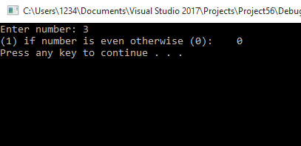

**TASK 2:**

1. Write a function named timesTen. The function should have an integer parameter named number. When timesTen is called, it should display the product of number times ten.

**CODE:**

#include <iostream>

using namespace std;

void timesTen(int number);

int main()

{

int number;

cout << "Enter number: ";

cin >> number;

timesTen(number);

system("pause");

return 0;

}

void timesTen(int number)

{

cout << number * 10;

cout << endl;

}

**Output:**

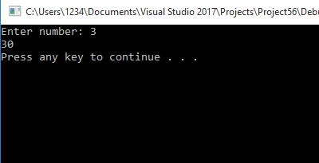

**Task 3:**

1. Write a function asks the user to enter the radius of the circle and then returns that number as a double. Write another function that takes this radius as input and returns the area of circle.-

**Code:**

#include <iostream>

using namespace std;

double radius(int);

double area(double);

int main()

{

double radius_;

cout << "Enter number: ";

cin >> radius_;

cout << "radius in double: " << radius(radius_) << endl;

cout << "area is: " << area(radius(radius_)) << endl;

system("pause");

return 0;

}

double radius(int rad)

{

return rad;

}

double area(double rad)

{

return 2 * 3.14 * rad;

}

**Output:**

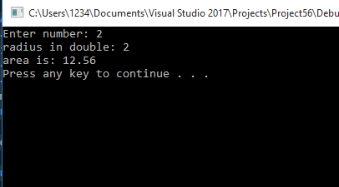

**Task 4:**

Write a program with a function that takes two int parameters, adds them together, then returns the sum. In main, program should ask the user for two numbers, then call the function with the numbers as arguments, and tell the user the sum.

**Code:**

#include <iostream>

using namespace std;

int addition(int, int);

int main()

{

int num1, num2;

cout << "Enter numbers: ";

cin >> num1 >> num2;

cout << "sum is: " << addition(num1, num2);

system("pause");

return 0;

}

int addition(int num1, int num2)

{

return(num1 + num2);

}

**Output:**

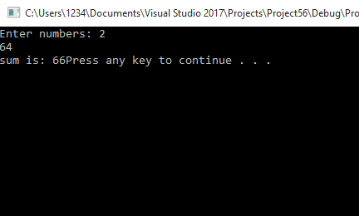

**Task 5:**

1. Write a value returning function that receives three integers and returns the largest of the three. Assume the integers are not equal to one another.

**Code:**

#include <iostream>

using namespace std;

int largest_num(int num1, int num2, int num3);

int main()

{

int num1, num2, num3;

cout << "enter a number:";

cin >> num1;

cout << "enter a number:";

cin >> num2;

cout << "enter a number:";

cin >> num3;

cout << "largest number is : " << largest_num(num1, num2, num3) << endl;

system("pause");

return 0;

}

int largest_num(int num1, int num2, int num3)

{

if (num1 > num2 && num1 > num3)

{

return num1;

}

else if (num2 > num1 && num2 > num3)

{

return num2;

}

else if (num3 > num2 && num3 > num1)

{

return num3;

}

}

**Output:**

